Mobicity (Mobile shopping E-commerce website)
Technology used: PHP, HTML, CSS, JQuery
Tools: XAMPP (Apache)
Domain: Business to Consumer (E-tailer)
Vision: To provide a digital platform for buying mobile phones of various brands through Electronic commerce and offer secure online transactions through a payment gateway.
Mission:
- Customer prioritization
- Widest selection of products
- Varied Brands available at a single website
- Offer lowest prices
- Provide best selection of products
- Utmost convenience of customer is taken care of
SWOT Analysis: SWOT analysis is a strategic planning technique used to help a person or organization identify the Strengths, Weaknesses, Opportunities, and Threats related to business competition or project planning. It is intended to specify the objectives of the business venture or project and identify the internal and external factors that are favorable and unfavorable to achieving those objectives. Users of a SWOT analysis often ask and answer questions to generate meaningful information for each category to make the tool useful and identify their competitive advantage.
Strengths and Weakness are frequently internally-related, while Opportunities and Threats commonly focus on environmental placement.
Strengths: characteristics of the business or project that give it an advantage over others.
Weaknesses: characteristics of the business that place the business or project at a disadvantage relative to others.
Opportunities: elements in the environment that the business or project could exploit to its advantage.
Threats: elements in the environment that could cause trouble for the business or project.
SWOT analysis aims to identify the key internal and external factors seen as important to achieving an objective. SWOT analysis groups key pieces of information into two main categories:
- Internal factors — the strengths and weaknesses internal to the organization.
- External factors — the opportunities and threats presented by the environment external to the organization.
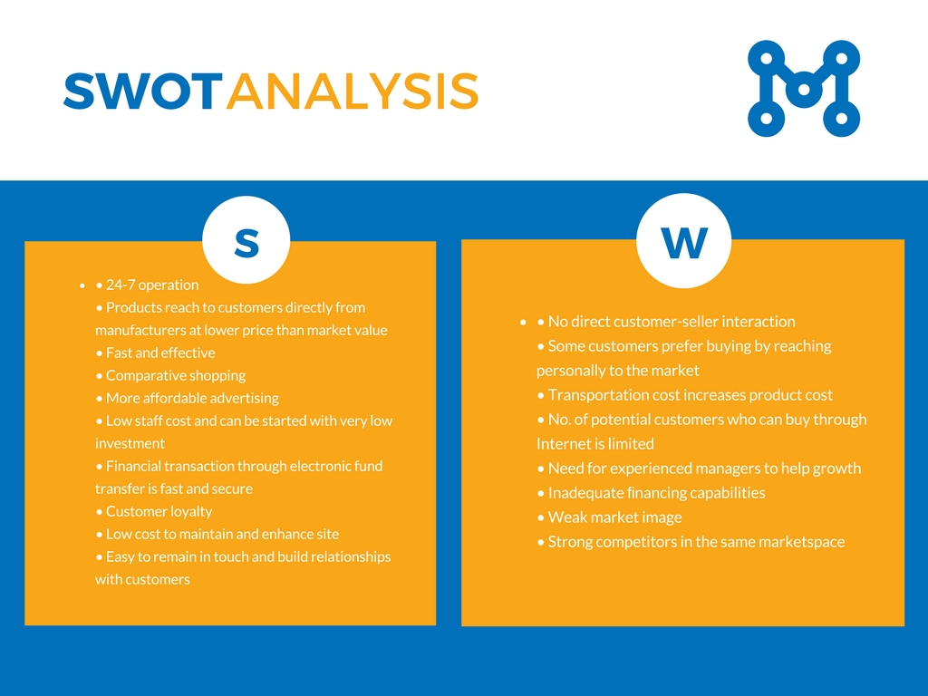
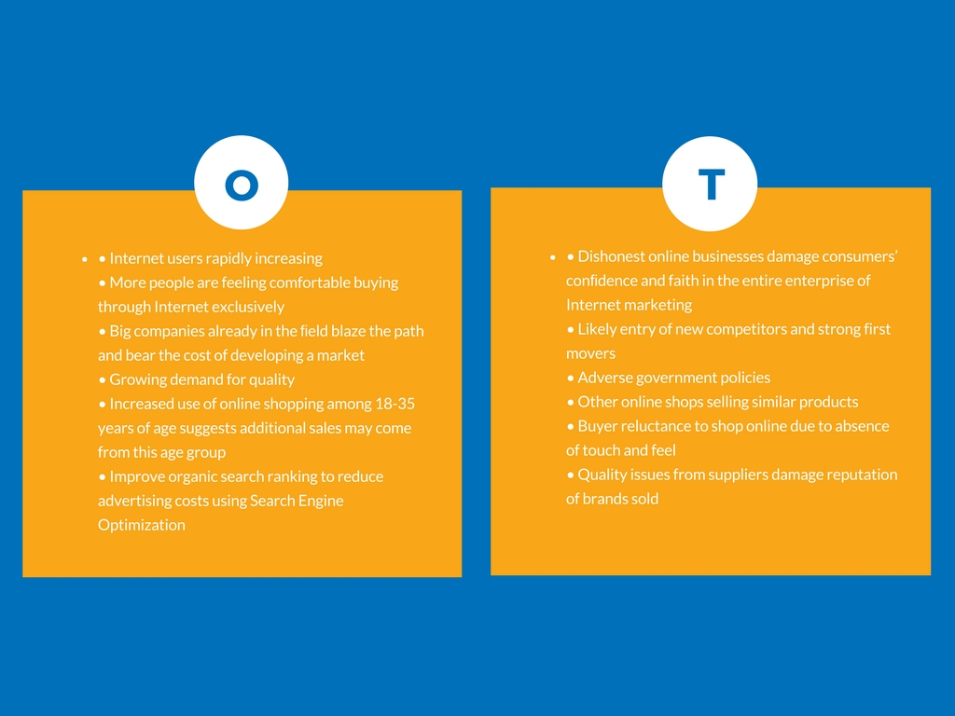
Target Audience: 15-65 years of age
Business and Revenue Model: Sales Revenue Model
Content: Static Content (Digital Content – Catalog and YouTube Videos)
Ecommerce Presence Map: Online
Although it’s happened slowly for some, the vast majority of small to medium-sized businesses have realized that if they want to grow, they need to shift a significant portion of their attention – and budgets – to the online marketplace. With more consumers than ever buying products from the comfort of their own homes, the companies that are slow to adapt to the changing retail landscape are apt to fall by the wayside.
An e-commerce presence map helps you clearly define what types of presence you want to have, what platforms to use and which activities within those platforms can benefit you the most based on your business model.
Milestones:
- Planning: Determining the vision and mission statement along with study of available competitors and current marketplace.
- Website Development: Acquiring the content and developing a web design and arrange for hosting.
- Web Implementation: Actual implementation of Web Development Plan and focus on search engine optimization.
- Social Media Plan: Identify various social media platforms with the strongest presence and effect in marketplace.
- Social Media Implementation: Develop Facebook, Instagram, Pinterest, Twitter and Google+ presence and connect to the potential customers for developing a relationship with them and construct a strong and loyal customer base.
Software Development Life Cycle Stages (SDLC Stages):
Software Development Life Cycle (SDLC) is a process used by the software industry to design, develop and test high quality software. The SDLC aims to produce a high-quality software that meets or exceeds customer expectations, reaches completion within times and cost estimates. SDLC is a framework defining tasks performed at each step in the software development process.
SDLC is a process followed for a software project, within a software organization. It consists of a detailed plan describing how to develop, maintain, replace and alter or enhance specific software.

- System Analysis/Planning: Display products using Product Catalog, Provide a Shopping Cart along with secure Payment Gateway, Maintain a Customer and Sales Database, Maintain an Inventory Management System.
- System Design: Providing a simple Design for hardware and software components.
- Building the System: Completely in-house - build in-house and hosting in-house (Using Pre-built Templates)
- Testing: Unit Testing, Integration Testing, Functional Testing, Usability Testing.
- Implementation of service and delivery: After the process of order confirmation is completed, the delivery is to be done. Delivery is done using a third party logistics service.
- Maintenance: Regular Updates of New products available.
Security: Defense against SQL Injection and XSS scripting.
Features:
- Search: Makes it easy to find desired products.
- Cart: Powerful shopping cart with easy checkout.
- Catalog: Descriptive product details with Information Transparency.
- Payment gateway: Allows you to have an easy to pay option.
- Personalization and customization: Allows you to customize and personalize your requirements.
- Brand filtration: Availability of multiple brands to choose from.
Marketing:
- Viral Marketing
- Email Marketing
- Social Marketing
- Offline Marketing
Payment option: DigiPay (Payment Gateway)
- Net Banking
- Paytm
- Debit Card
- Credit Card
Extra Features:
- Product Categories & Multi-Level sub categories
- Add/Edit/Remove categories, products, manufacturers, customers, and reviews
- Advanced Product Search facility
- Reviews on Products & their ratings
- Products on Sale
- User Account creation
- User Account maintenance
- Shopping cart status
- E-mail notifications
- Secure transactions with SSL
- Statistics for products and customers
- Contact customers directly via email or newsletters
- Manage Orders
- Shipping module integration
- Payment gateway integration

